Permanently Progressing?

Building secure futures for children: Phase 2 Middle childhood
Our names are Maggie, Helen and Paula. We work at the University of Stirling.
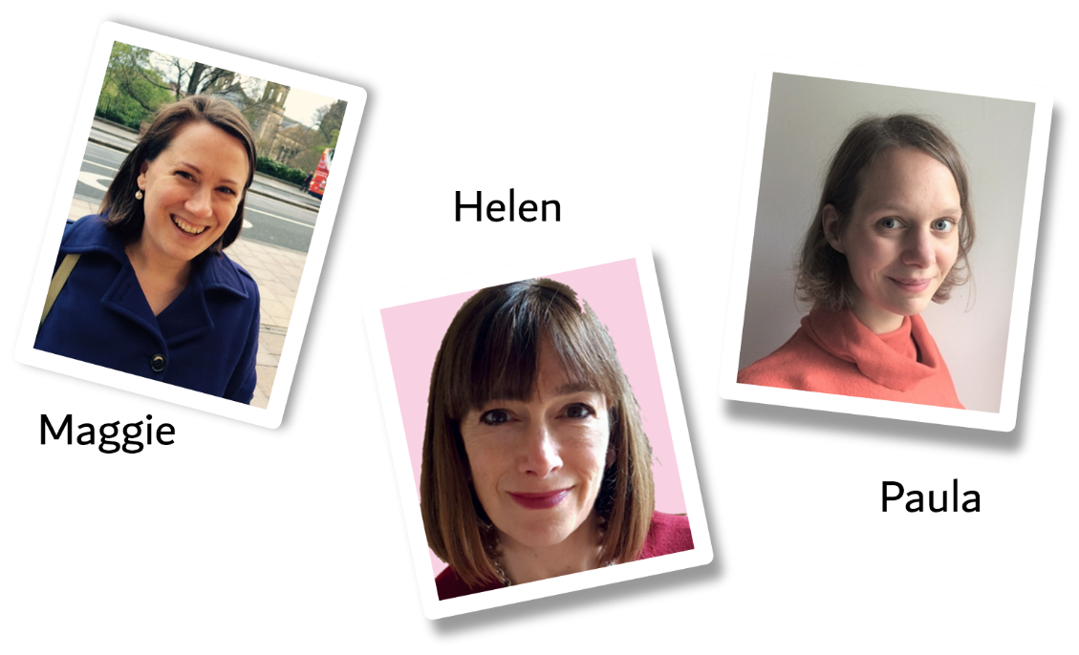

An invitation to take part in a research study
We are asking you if you would like to take part in a study to help us understand the experiences of children and young people growing up in kinship, foster and adoptive families. This is the second phase of a three-phase study. We hope the study will help improve the ways that adults care for children and young people in the future. The ethics panels at University of Stirling and Lancaster University have checked the plans for the research to make sure it is OK to go ahead. They have given ethical approval for the research.
We would like to learn a little bit about you and ask some questions. We will ask about things like:
- People and things that are important to you
- What you like to do to have fun
- What you think about school and learning
- People and things that help you be happy and healthy

Do I have to take part?
No, you do not have to take part. It is totally up to you. If you say yes and then change your mind, that is ok, and no one will mind.

What will happen if I take part?
We would like to meet up to talk to you. Maggie, Helen or Paula could come to your house and meet you in person, or we can have a chat using Zoom or Microsoft Teams.
We know that talking to someone who you don’t know might be hard. If you want, we can bring some things for us to do together while we talk. You can choose what you would like to do.
If you have questions, we can have a chat before you decide whether to take part. We have also put some videos on our website with more information (see below).

What if I don’t want to talk about something you are asking me?
You do not have to talk about anything that you don’t want to, and you can stop our chat whenever you like. It is YOUR choice.

What will happen to the information that I tell you?
If it’s okay with you, we’ll record our chat on an audio recorder. The audio recorder keeps the information safe and only the people working on the project can listen to it. This will be typed up and saved on a secure computer at the university.
We will read and think about what children have said to us and use this information to write a report. We will not include any names or any information that could let people know who you are.
We will only share the information you provide with other people if we are worried about you and need to say something to keep you safe.

I would like to take part, what should I do?
You can contact us on 07716 483506 or email Paula at paula.jacobs@stir.ac.uk. Or if you prefer, you can ask your carer or parent to contact us.
Thank you for reading this – please ask any questions if you want to.
More information about the research and alternative versions of this information sheet are available at the study’s website (www.permanentlyprogressing.stir.ac.uk).

